Task C1 → C2

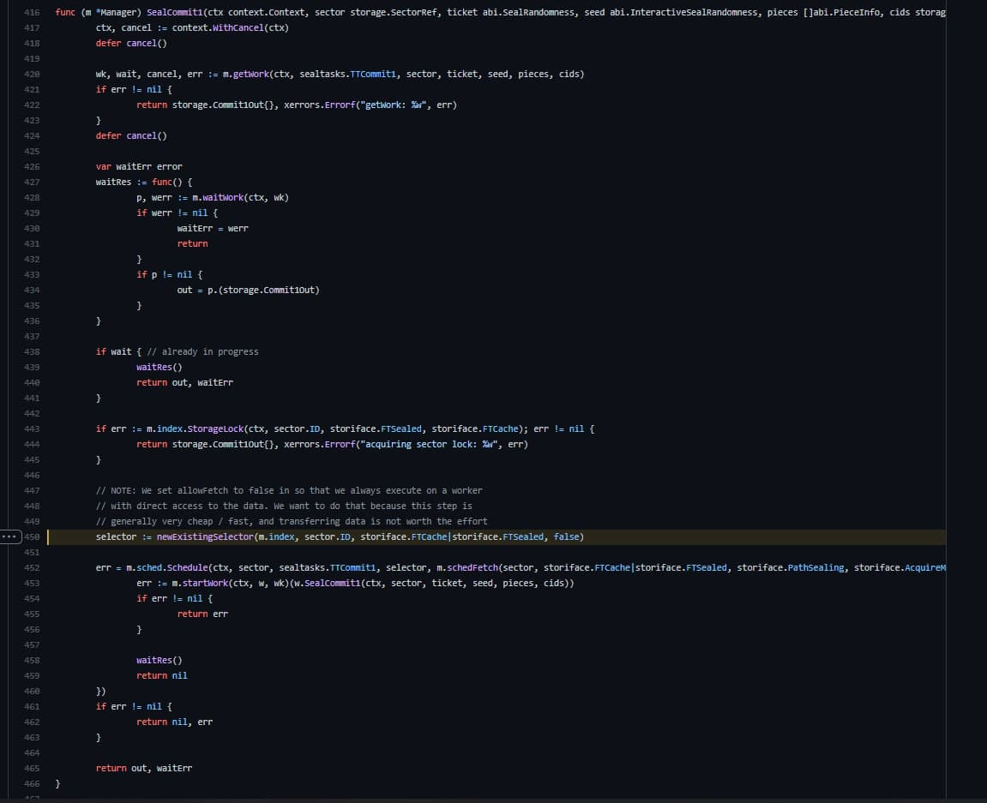

C1 always runs on the same worker as PC2 because it is just reading *20MB of data, so no fetch is necessary because it is a cheap operation. Data will be transferred from C1 to C2 Worker by JSONRPC after C1 is completed.

